FWC Flight-Wood
Consulting AB

Mikael Hedlén
Energigatan 7 11/22/2026
SE-734 32 Hallstahammar, Sweden
Telefon +46-22051500
Fax +46-22051540
Mobile +46-701753748
mikael.hedlen@flight-wood.co m

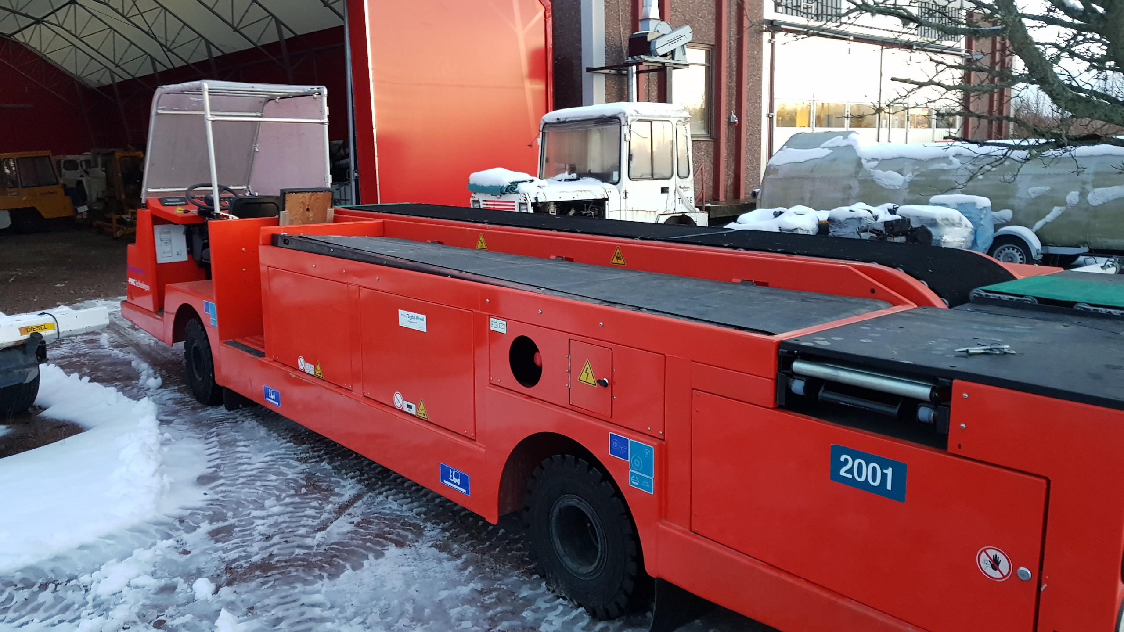 .
With reference to previous discussions we can offer the following:

Item/Manufacturer | Remarks | Price in SEK(net) per unit
Ramp Snake | FMC Ramp snake. As inspected in working condition. ex Hallstahammar. | On Request ex Hallstahammar
All prices is ex tax, vat and customs fees.

All items are offered on the availability and delivery of my customers and all offers are based on "first & come buy" / " as-it-is/where is basis" and are subject to prior sale.

Mikael Hedlén

